Sal f
Golden Valley High School
Wm. S. Hart Union High School District
“Home of the Grizzlies”
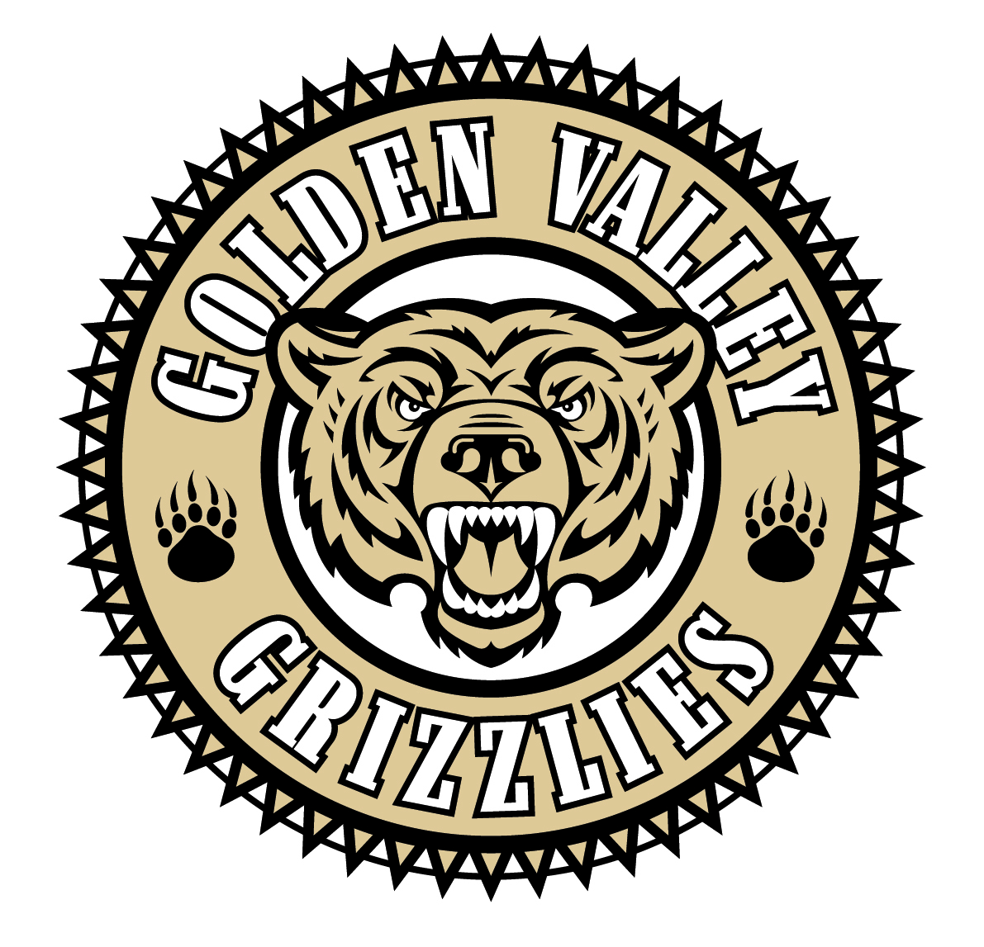
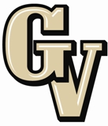

Parent Advisory Council (PAC) Meeting
January 27, 2014
6:30 PM

AGENDA

- PAC Meeting Welcome Sal Frias

- Secretary’s Report ACTION Jennifer Ryan

- Treasurer’s Report ACTION Emily Curtis

- President’s Report Sue Alterman

- District Advisory Council (DAC) Report Monica Camacho

- Parent Communications Council (PCC) Report Cherise Moore

- AB 1266 Sex Segregated School Programs and Activities Sal Frias

- AB 256 Bullying: Grounds for Suspension and Expulsion Sal Frias

- Advanced Placement Christine Benitez

- 2014 Spring Testing Update Sal Frias

- WASC Report Carolyn Hoffman

Announcements: -Drum-a-thon at Food 4 Less on Soledad & Whites Cyn. On 2/1 from 8 am – 6 pm
-ASB Hoopla Week (Feb. 3-7)
-RK Downs Jazz Festival @ West Ranch HS on 2/6
-No School on Friday, Feb. 14th for District Wide Common Core Symposium
-No School on Monday, Feb. 17th for President’s Day
-ASB Movie Night, Feb. 19th at 7 pm
-Band Music Recital and Chili/ BBQ Cook Off on Saturday, Feb. 22 @ 6 pm

Next Meeting: February 24, 2014

The mission of GVHS is to provide a quality education to a diverse student population, develop each student’s maximum potential, and prepare students for success in the global community.

